# Project assessment

## Criteria

### Unit code and name

WebCluster3

ICTWEB431 – Create and style simple markup language documents

ICTWEB433 – Confirm accessibility of websites

ICTWEB444 – Create responsive website layout

ICTWEB452 – Create a markup language document

### Qualification/Course code and name

ICT40120 | Certificate IV in Information Technology

## Student details

### Student number

881293009

### Student name

Lakshya Goyal

## Assessment declaration

*Note: If you are an online student, you will be required to complete this declaration on the TAFE NSW online learning platform when you upload your assessment.*

This assessment is my original work and has not been:

* plagiarised or copied from any source without providing due acknowledgement.
* written for me by any other person except where such collaboration has been authorised by the Teacher/Assessor concerned.

### Student signature and date

Lakshya Goyal

12/06/2024

Version: 20230413

Date created: 16 November 2021

For queries, please contact:

Technology and Business Services SkillsPoint

© 2022 TAFE NSW  
RTO Provider Number 90003 | CRICOS Provider Code: 00591E

This assessment can be found in the: [Learning Bank](https://share.tafensw.edu.au/share/access/searching.do?doc=%3Cxml%2F%3E&in=P7ac4831b-430a-4b8d-8b56-f7b32ed5b9cf&q=&type=standard&sort=rank&dr=AFTER)

The contents in this document is copyright © TAFE NSW 2022 and should not be reproduced without the permission of TAFE NSW. Information contained in this document is correct at the time of printing: 12 June 2024. For current information please refer to our website or your Teacher/Assessor as appropriate.

## Assessment instructions

Table 1 Assessment instructions

| Assessment details | Instructions |
| --- | --- |
| **Assessment overview** | The aim of this assessment is to assess your knowledge required to scope web page requirements and to create and implement designs according to client requirements. It also assesses your skills and knowledge required to design and create basic markup language documents and cascading style sheets (CSS) in order to define the structure and style of a website, while adhering to international and Australian industry standards and practices. |
| **Assessment event number** | 2 of 2 |
| **Instructions for this assessment** | This is a project-based assessment that assesses your knowledge and performance of the unit.  This assessment is in 5 parts:  Part 1: Understanding the user requirements.  Part 2: Planning the website.  Part 3: Creating the website.  Part 4: Test and validate the website.  Part 5: Taking feedback from the user.  And is supported by:   * Supporting documents:   + [Cl_DesignDevelopWeb_AE_Pro2of2_Appx_AccessibilityChecklist.docx](https://share.tafensw.edu.au/share/items/4b4c6759-549c-4629-ba0d-c5b7bbd6ece8/0/?attachment.uuid=ae600994-d6bc-4dd1-9b61-9d72f8afaab1)   https://share.tafensw.edu.au/share/items/4b4c6759-549c-4629-ba0d-c5b7bbd6ece8/0/?attachment.uuid=ae600994-d6bc-4dd1-9b61-9d72f8afaab1   * + [Cl_DesignDevelopWeb_AE_Pro2of2_Appx_AudienceAnalysis.docx](https://share.tafensw.edu.au/share/items/4b4c6759-549c-4629-ba0d-c5b7bbd6ece8/0/?attachment.uuid=306e8e07-7c8a-48eb-9d57-6e1937a36832)   https://share.tafensw.edu.au/share/items/4b4c6759-549c-4629-ba0d-c5b7bbd6ece8/0/?attachment.uuid=306e8e07-7c8a-48eb-9d57-6e1937a36832   * + [Cl_DesignDevelopWeb_AE_Pro2of2_Appx_TextToSpeech.docx](https://share.tafensw.edu.au/share/items/4b4c6759-549c-4629-ba0d-c5b7bbd6ece8/0/?attachment.uuid=86949fb8-b896-4f16-b1d0-99f135240b6e)   https://share.tafensw.edu.au/share/items/4b4c6759-549c-4629-ba0d-c5b7bbd6ece8/0/?attachment.uuid=86949fb8-b896-4f16-b1d0-99f135240b6e   * + [Cl_DesignDevelopWeb_AE_Pro2of2_Appx_VisionManagement.docx](https://share.tafensw.edu.au/share/items/4b4c6759-549c-4629-ba0d-c5b7bbd6ece8/0/?attachment.uuid=900b3b78-1487-46f9-8d7a-40e6474eddcd)   https://share.tafensw.edu.au/share/items/4b4c6759-549c-4629-ba0d-c5b7bbd6ece8/0/?attachment.uuid=900b3b78-1487-46f9-8d7a-40e6474eddcd   * + [Cl_DesignDevelopWeb_AE_Pro2of2_Appx_WebsiteRequirement.docx](https://share.tafensw.edu.au/share/items/4b4c6759-549c-4629-ba0d-c5b7bbd6ece8/0/?attachment.uuid=750df3df-258a-4f1c-a2ae-a41a8774248a)   https://share.tafensw.edu.au/share/items/4b4c6759-549c-4629-ba0d-c5b7bbd6ece8/0/?attachment.uuid=750df3df-258a-4f1c-a2ae-a41a8774248a   * + [Cl_DesignDevelopWeb_AE_Pro2of2_Appx_TextAndImages.zip](https://share.tafensw.edu.au/share/items/4b4c6759-549c-4629-ba0d-c5b7bbd6ece8/0/?attachment.uuid=80f34d0e-8ccf-439c-9ef7-0d7fb5e3eab3)   https://share.tafensw.edu.au/share/items/4b4c6759-549c-4629-ba0d-c5b7bbd6ece8/0/?attachment.uuid=80f34d0e-8ccf-439c-9ef7-0d7fb5e3eab3   * Assessment checklist * Assessment feedback   **Note**: This assessment may contain links to external resources. If a link does not work, copy and paste the URL directly into your browser. |
| **Submission instructions** | On completion of this assessment, you are required to submit it to your Teacher/Assessor for marking. Where possible, submission and upload of all required assessment files should be via the TAFE NSW online learning platform.  It is important that you keep a copy of all electronic and hardcopy assessments submitted to TAFE and complete the assessment declaration when submitting the assessment. |
| **What do I need to do to achieve a satisfactory result?** | To achieve a satisfactory result for this assessment you must answer all the questions correctly.  If a resit is required to achieve a satisfactory result it will be conducted at an agreed time after a suitable revision period. |
| **What do I need to provide?** | * TAFE NSW student account username and password. If you do not know your username and password, contact your campus or service centre on 131601. * Computer or other device with word processing software and internet access * Writing materials, if required |
| **What the Teacher/Assessor will provide** | Access to this assessment and learning resources, including the student workbook and any supporting documents or links. |
| **Due date**  **Time allowed**  **Location** | Refer to UAG for details  Nine hours (indicative only)  Assessment is to be completed out of class. |
| **Assessment feedback, review or appeals** | In accordance with the TAFE NSW policy *Manage Assessment Appeals,* all students have the right to appeal an assessment decision in relation to how the assessment was conducted and the outcome of the assessment. Appeals must be lodged within **14 working days** of the formal notification of the result of the assessment.  If you would like to request a review of your results or if you have any concerns about your results, contact your Teacher/Assessor or Head Teacher. If they are unavailable, contact the Student Administration Officer.  Contact your Head Teacher/Assessor for the assessment appeals procedures at your college/campus. |

## Specific task instructions

The instructions and the criteria in the tasks and activities will be used by the Teacher/Assessor to determine if you have satisfactorily completed this assessment event. Use these instructions as a guide to ensure that you demonstrate the required knowledge and skills.

Refer these instructions given carefully before proceeding with the Part 1 (Designing the website) assessment:

1. Go through the instructions carefully before attempting the project assessment.
2. Ask your instructor for the sample resources provided by TipToe Soles (the fictitious Shoe company used for this project) and Gelos Enterprises.
3. Use the templates provided to complete and document completion of each task.
4. Sample resources have been provided and should be used for reference purposes only. They are meant to provide a starting point for your designs.
5. The information in the scenarios and the resources provided are for inspiration. You may add on elements to enhance your work. *(Be mindful of the time allotted)*
6. Talk to your instructor for any clarifications.

# Scenario

You are working as an IT Website Lead Designer with Gelos Enterprises. Gelos is an IT organization with a proven track record in the web development and cybersecurity. As a policy, the organization not only serves multi-national companies, but a separate division also caters to the requirements of small sized organizations.

Gelos has been approached by TipToe Soles, a shoe manufacturing company based out of Texas, USA. The company has been manufacturing and providing the products as a white label to various other brands. The management of the shoe company now wishes to launch its own brand in the market at affordable costs.

TipToe Soles wants a responsive website to be developed for its first range of products to be launched shortly. The objective of creating a website is that customer can visit and make purchase from the comfort of their homes using a debit/credit card.

A meeting had been organized recently between the business development vertical of Gelos and the management of TipToe Soles to understand the requirements and discuss the financials.

The management visions the brand to be a to go footwear brand not just in the US but across the world. After US, they’re planning to open stores in Australia as well.

The first range of products that will be launched are the comfort or daily wear shoes targeting the 30+ customers. The website should have a minimalistic design to avoid any unnecessary distractions.

The management has provided a brief description of how they visualize the structure of their website. The website should have a main menu toward the left side of the screen with a banner across the home page wherein the latest arrivals shall be displayed. The main menu should contain about us, products, services, login, wish list, contact and search option tabs. The footer of the home page should include the hyperlinks to return policies, exchange policies, delivery policies, etc. And of course, each page should hold the brand logo at the top left corner. The colors used should be monochromatic but must not be too heavy on the eyes.

The website should be compatible on all devices such as laptop, mobile, iPad etc. The product section of the website should have the similar products are displayed in a list format and a payment gateway can be eventually integrated as well.

The brand logo and the website content shall be provided the TipToe Soles. The theme of the images to be used should be photography with a ratio of 4:3.

Since the company is confident about the quality of their products, they’re sure that website would experience high traffic and don’t want to face any compatibility or performance issues as any downtime would result in loss of business.

Further, it should comply with the existing state and local laws, as obviously no one likes to be sued. So, while developing the website, the accessibility concerns are to be taken care by Gelos and the team.

## Part 1: Understanding the user requirements

The first part of any project is to understand the client requirement that lays the foundation to the next processes and developments. In this section, you will be tested on your understanding of the scenario and the volume of quality information you can infer out to document the client’s requirements.

### Task 1 – Audience Analysis and understanding the requirements

The first task of any project is to understand the purpose and the target audience who will be using the product. In this scenario, the product is a website desired by the client. It becomes imperative to clearly document the requirements of the user as it converts into the actual product at a later stage.

For this task, use the template provided to document the requirements of the user.

You must not use the internet for help, use the correct jargons, and the same template provided to present the answer.

[Cl_DesignDevelopWeb_AE_Pro2of2_Appx_AudienceAnalysis](https://share.tafensw.edu.au/share/items/4b4c6759-549c-4629-ba0d-c5b7bbd6ece8/0/?attachment.uuid=306e8e07-7c8a-48eb-9d57-6e1937a36832)

### Task 2 – Identify the user requirements

Since we have documented the requirements of the user, it is now time to elaborate the purpose for designing a website. This includes identifying and defining the aspirations of the client with respect to the product.

Use the template provided to document the vision of the management on how they aspire their website to be used.

You must not use the internet for help, use the correct jargons, and the same template provided to present the answer.

[Cl_DesignDevelopWeb_AE_Pro2of2_Appx_VisionManagement](https://share.tafensw.edu.au/share/items/4b4c6759-549c-4629-ba0d-c5b7bbd6ece8/0/?attachment.uuid=900b3b78-1487-46f9-8d7a-40e6474eddcd)

### Task 3 – Develop the testing approach

1. After documenting the client’s requirement, we will be proceeding to deciding the mark-up language that you will be using to develop your website along with a specified list of tests and testing approach to be taken through the process.
2. Develop the browser testing approach to be used for testing the finished website, including appropriate test cases and a testing checklist.

To select the testing approach, you may choose a combination of at least three testing techniques mentioned here:

Functionality, Usability, Interface, Compatibility, Security, Performance, and database.

1. Select the most appropriate mark-up language to meet all the requirements for the site and mention why this is the best choice.

## Part 2: Planning the website

Once we have documented the requirements of the user, it is now time to document the product requirements. The client has briefly described in the scenario how they wish their website to look like and, in this part, you will further explore the client’s requirements and plan the website.

### Task 1 – Document website requirements

Using your understanding and the template provided, prepare a website requirement document for Gelos Enterprises.

You must not use the internet for help, use the correct jargons, and the same template provided to present the answer.

[Cl_DesignDevelopWeb_AE_Pro2of2_Appx_WebsiteRequirement](https://share.tafensw.edu.au/share/items/4b4c6759-549c-4629-ba0d-c5b7bbd6ece8/0/?attachment.uuid=750df3df-258a-4f1c-a2ae-a41a8774248a)

### Task 2 – Develop a structure of the website

Determine and organise the content required for the website:

1. Create a content inventory, including the following (this can be represented in a table or spreadsheet):
   * Existing content provided by the client.
   * Analyse the client requirements to determine any additional content required by the client.
   * Analyse the user requirements to determine any additional content required by the users.

|  |  |
| --- | --- |
| Content Provided by Client | Description |
| Brand logo | Logo of TipToe Soles brand. |
| Website content | Text content for various pages such as about us, products, services, login, wish list, contact, etc. |
| Product images | Photography of comfort or daily wear shoes in a 4:3 ratio. |
| Policies (return, exchange, etc.) | Information regarding return, exchange, and delivery policies. |

**Additional Content Required by Client**

* Latest arrivals banner for home page.
* Payment gateway integration.
* Accessibility compliance measures.
* High traffic handling and performance optimization.
* Compliance with state and local laws.

**Additional Content Required by Users**

* Detailed product descriptions.
* Product categories and subcategories.
* Size and color options for products.
* Customer reviews and ratings.
* FAQs section addressing common queries.
* Privacy policy and terms of service.

1. Group and prioritise the content into categories (pages and subpages) so the content will be logical and accessible to users.

**Content Prioritization**

1. **Home Page**
   * Latest arrivals banner.
   * Main menu.
   * Footer with policy links.
   * Brand logo.
2. **About Us**
   * Information about TipToe Soles.
   * Brand philosophy and history.
   * Mission and vision statements.
3. **Products**
   * List of comfort or daily wear shoes.
   * Product categories and subcategories.
   * Detailed product descriptions.
   * Size and color options.
   * Product images.
   * Customer reviews and ratings (if available).
4. **Services**
   * Information on services offered (e.g., customization, warranties).
5. **Login**
   * User authentication and account management.
6. **Wish List**
   * Feature allowing users to save desired products for later.
7. **Contact**
   * Contact information (address, phone, email).
   * Contact form for inquiries.
8. **Search**
   * Search functionality for easy navigation.
9. **Policies**
   * Return policy.
   * Exchange policy.
   * Delivery policy.
   * Privacy policy.
   * Terms of service.
10. **FAQs**

* Commonly asked questions and answers.

1. **Accessibility**

* Compliance with accessibility standards.

1. **Payment Gateway**

* Integration for secure online transactions.

1. **Performance Optimization**

* Measures to handle high traffic and ensure uptime.

1. **Legal Compliance**

* Adherence to state and local laws.
* GDPR compliance (if applicable).

1. Using the information from the previous step, create a digital sitemap diagram of the overall website hierarchy based on your grouped content.

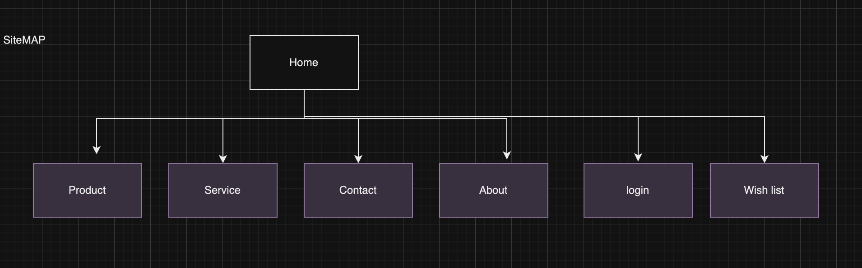

1. Create digital wireframes as templates for the page layout, one for the home page and one or more for internal pages, for both desktop and mobile versions.

Home page deskto

Footer

Products

Welcome to TipToeSoles

Banner

- Soft leather uppers and lightly padded collar  
- Plush footbed for added comfort  
- Recycled heel grip  
- Flexible and grippy outsole with 10% recycled material

Work and Walk.jpg

- Soft leather uppers  
- Breathable mesh lining  
- Removable footbed with soft mesh sock lining   
- Contoured footbed with additional heel padding  
- Orthotic friendly

Logo

About

Home

Service

Contacts

Login

Wish list

Search Bar

Navigation

Gary Tan.jpg

Heavenly Black.jpg

- Upper is scuff, stain & water-resistant  
- Breathable & soft foam backed mesh lining  
- Padded collar is super soft on the heel  
- Pull-tab for easy fitting  
- Metal eyelet detail

products.html

Navigation

Home

Products

Contacts

About

Service

Login

Wish list

Search Bar

Logo

Male

Females

IMG

IMG

Link

Link

Footer

Logo

Home

Products

Service

Contacts

About

Login

Wish list

Search Bar

Welcome to TipToeSoles

Work and Walk.jpg

Expand

Gary Tan.jpg

Expand

Heavenly Black.jpg

Expand

Footer

Home

Contacts

About

Service

Login

Wish list

Search Bar

Logo

Products

IMG

Link

IMG

Link

Footer

Use may use MS Word or MS PowerPoint to create your diagrams/designs.

Submit the content inventory, digital sitemap and digital wireframe screenshots as evidence.

You must not use the internet for help, use the correct jargons, and the same template provided to present the answer.

### Task 3 – Accessiblity planning

Accessibility refers to the ability of individuals with special needs to perceive, comprehend, navigate, and engage with websites and tools, as well as their ability to contribute equitably and without barriers.

Understanding the diverse audience of the client, use the template provided to prepare an accessibility checklist as per the web standards and list the benefits of integrating text-to-speech option that shall be followed while developing the website.

You must not use the internet for help, use the correct jargons, and the same template provided to present the answer.

[Cl_DesignDevelopWeb_AE_Pro2of2_Appx_AccessibilityChecklist](https://share.tafensw.edu.au/share/items/4b4c6759-549c-4629-ba0d-c5b7bbd6ece8/0/?attachment.uuid=ae600994-d6bc-4dd1-9b61-9d72f8afaab1)

[Cl_DesignDevelopWeb_AE_Pro2of2_Appx_TextToSpeech](https://share.tafensw.edu.au/share/items/4b4c6759-549c-4629-ba0d-c5b7bbd6ece8/0/?attachment.uuid=86949fb8-b896-4f16-b1d0-99f135240b6e)

### Task 4 – Conduct client meeting

Now that you have identified the user requirements, testing approach, structure of the website and did the accessibility planning, you need to consult with clients and discuss the digital sitemap and digital wireframe that you have created. For this, you will have a face-to-face meeting and client regarding the website requirements and development plan. You will also inform them the protocol followed and security procedures to ensure that client’s data is safe and secure.

The agenda items for this formal meeting are as follows:

1. Confirm the user requirements that you have documented in Part 2 Task 1.
2. Discuss the structure of the plan by sharing digital sitemap and digital wireframe.
3. Ask open-ended questions for clarification (if needed).
4. Confirm the user requirements and the structure of the website.
5. Obtain client feedback and amend layout if required

This role play will take approximately 10 to 15 minutes. To understand the assessment criteria for this role play, see Assessment checklist.

Before participating in this role play, make sure that you have completed Part 1 and Part 2 Task 1, 2 and 3 for this assessment.

**Role of the student being assessed**

During the role play make sure that you use:

* clear, simple language and plain English.
* appropriate conventions, protocols and tone for your audience.
* listening and inclusive questioning techniques.

The Assessor may ask questions while the demonstration is taking place, or if appropriate directly after the activity has been completed.

## Part 3: Creating the website

In this part, you will be tested on your website development skills. Take reference from the previous task and information gathered to develop a website as desired by the client. In this section, we will explore the elements and components involved in the development process.

### Task 1 – Develop a website

Using a text editor and the mark-up language identified in Part 2, create the structured and formatted website for the client. **Note: You must not use a program that generates code**.

Refer to the client’s requirements and organisational standards, as well as relevant industry standards, and ensure that your website follows these.

Include the following:

1. Create and use an appropriate directory structure for the website.
2. Build the page structure for your webpages using essential basic elements.
3. Create at least three pages using the supplied content [Cl_DesignDevelopWeb_AE_Pro2of2_Appx_TextAndImages.zip](https://share.tafensw.edu.au/share/items/4b4c6759-549c-4629-ba0d-c5b7bbd6ece8/0/?attachment.uuid=80f34d0e-8ccf-439c-9ef7-0d7fb5e3eab3) from the client.
4. Each page must include:
   * A navigational menu of text links providing access to all pages
   * A footer with appropriate utility links and social media icons
   * Company logo, which includes a link back to the home page
   * A current page indicator to clearly show a visitor where they are within the site.
5. Use semantically correct structural mark-up to define additional sections of each page as needed.
6. Style, format and lay out the pages using CSS:
   * Use one external CSS file for all styles i.e., no inline or internal styles.
   * Use consistent styles and layout across the site, including appropriate use of font stack, colours, line-spacing, etc.
   * Do not add unnecessary elements or attributes – use existing elements as selectors wherever possible.
   * Use ‘class’ and ‘id’ attributes appropriately.
   * Style hyperlinks appropriately for different states, such as visited and hover – do not use the default styles.
   * Style the current page indicator appropriately.
   * Use monochromatic colour theme.

Submit the code and the HTML link for the website developed as evidence.

## Part 4: Test and validate the website

Now that you have completed creating the website, it’s time for you to test and validate it. Record your test results (including screenshots where indicated) in a word-processed document to provide to the client. Use specialised language where appropriate.

### Task 1 – Test and validate the website created

1. Using the test approach and test cases that you created in Part 1, test your website and complete your testing checklist according to organizational procedures. Make sure that your testing includes the following:
   1. Test your website in two common browsers; if you have difficulty accessing different browsers and versions, you can use an online testing site such as [Browser Shots](http://browsershots.org/) (Long URL: https://browsershots.org/) (include screenshots)

|  |  |
| --- | --- |
| safari | Chrome |
|  |  |

* 1. Validate your website to ensure it meets web standards (include screenshots).

W3C cheeker

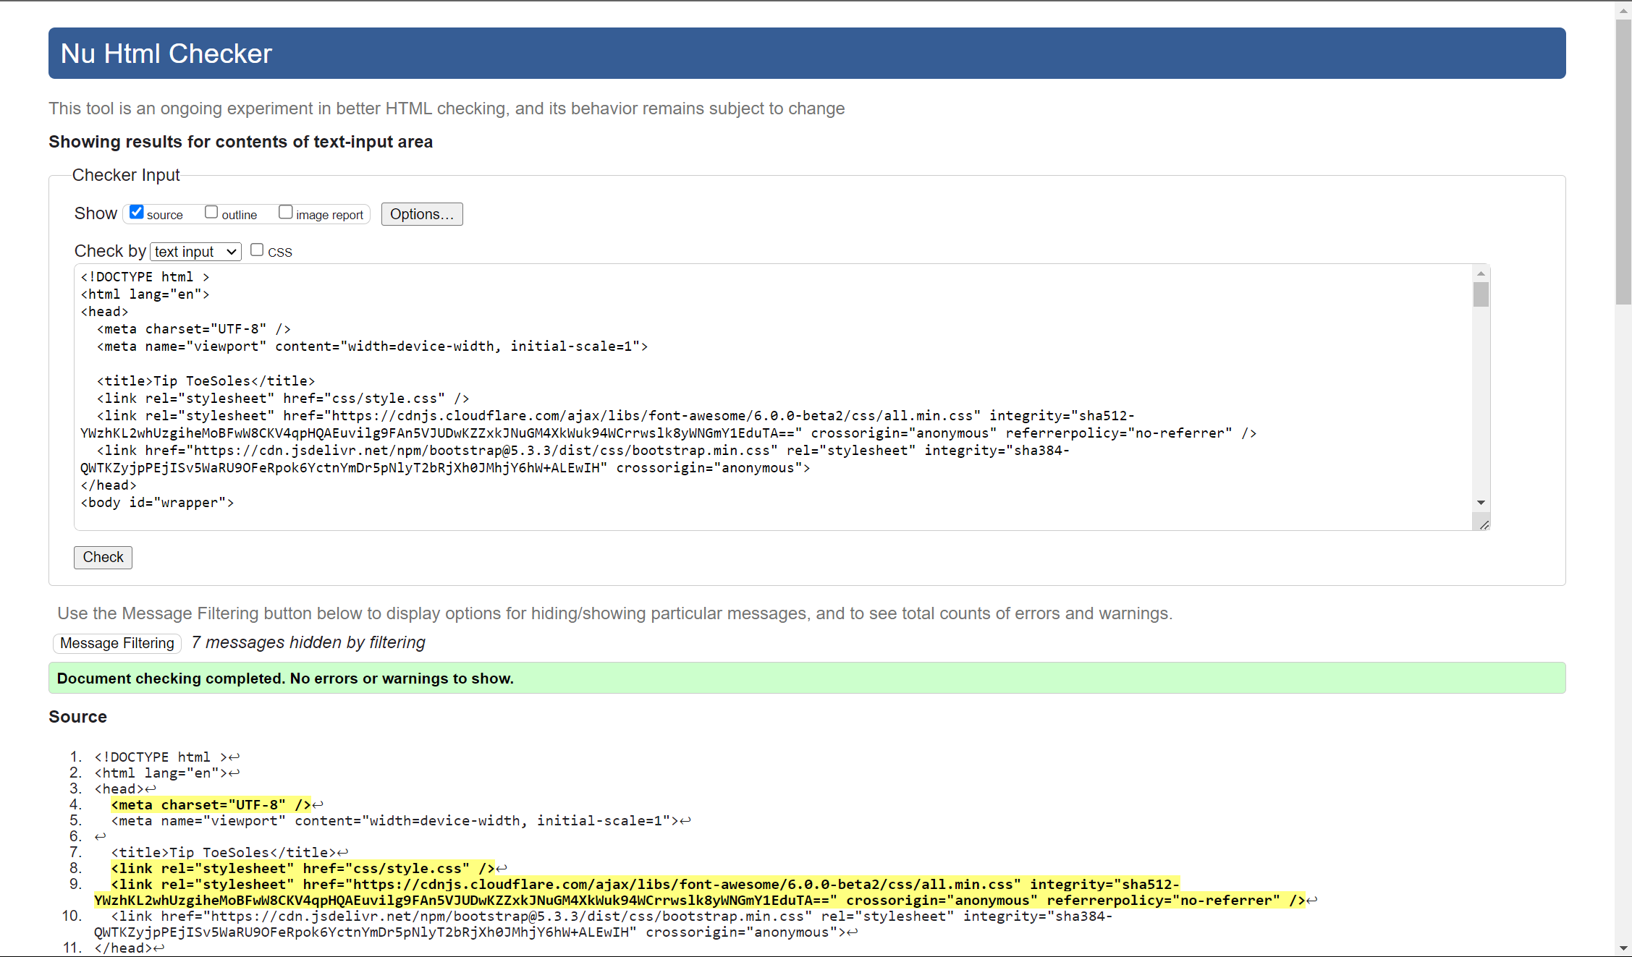

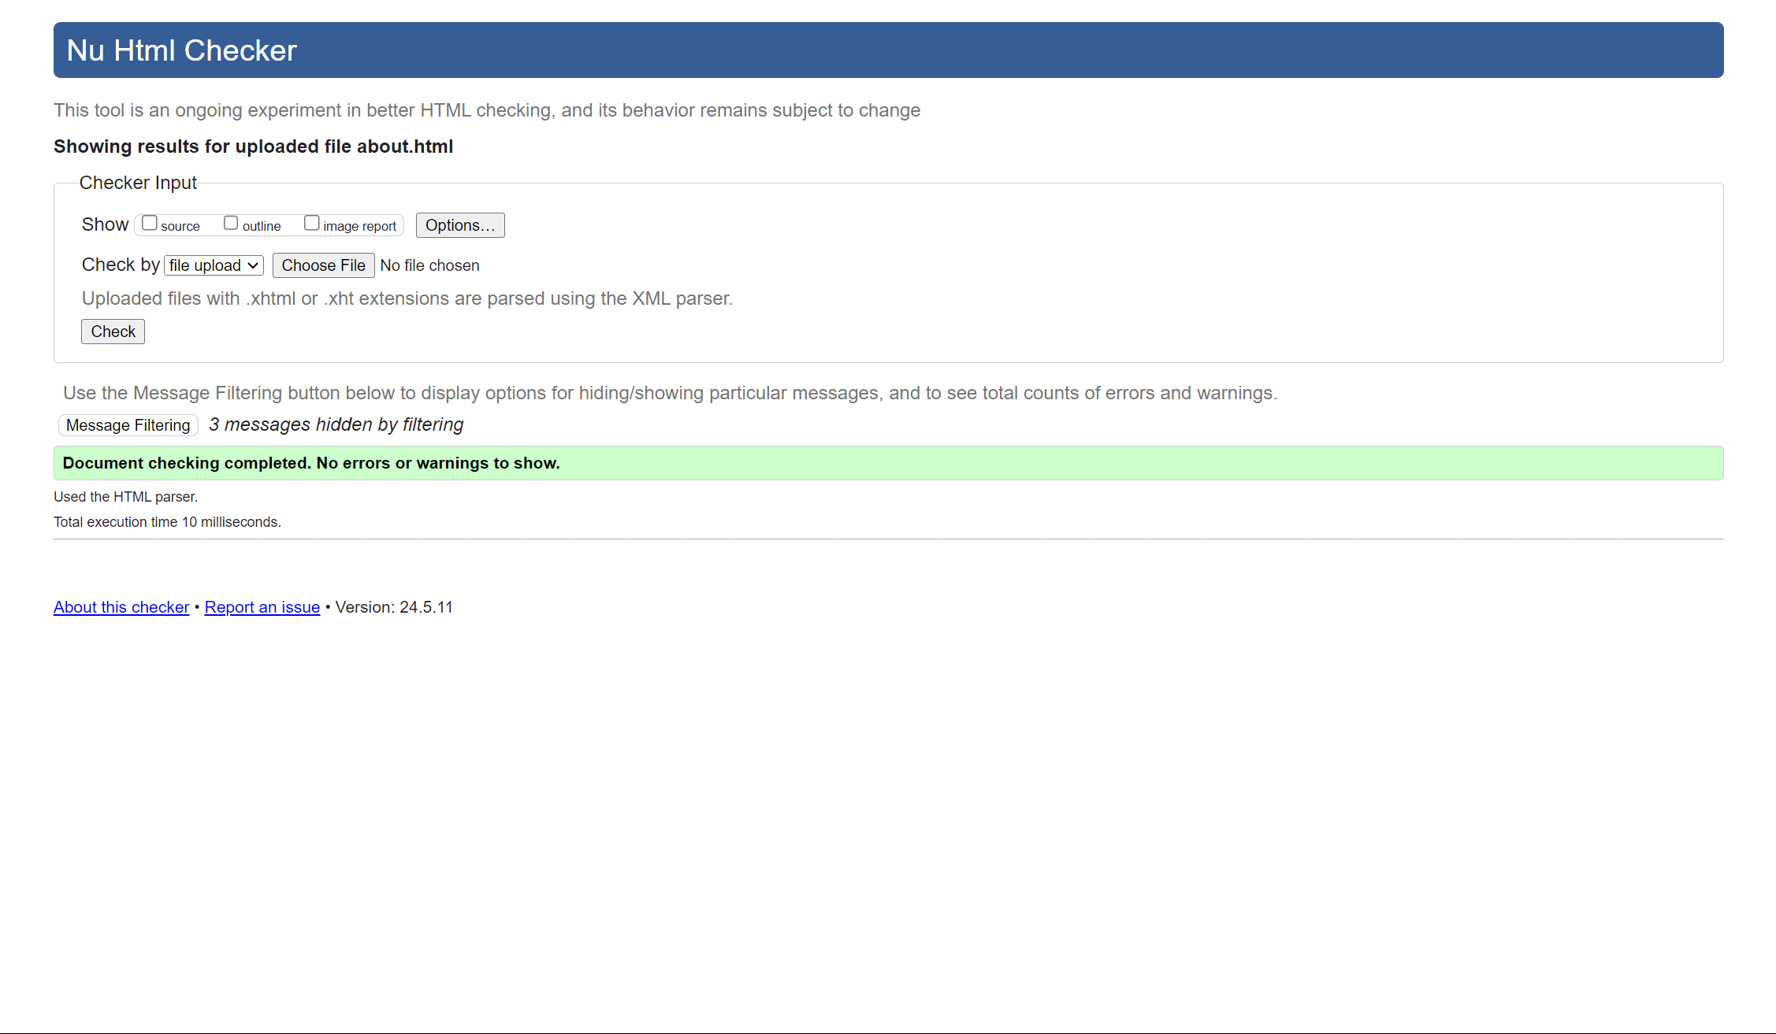

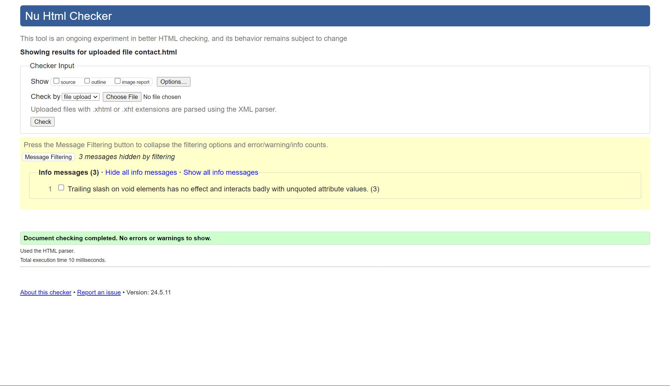

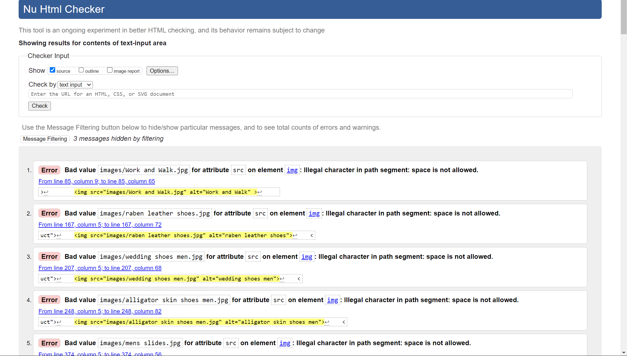

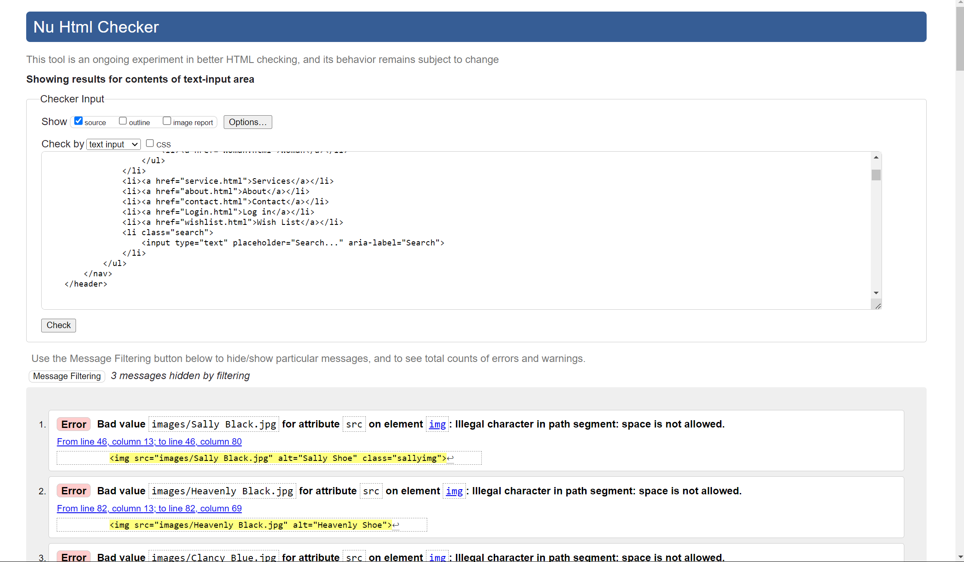

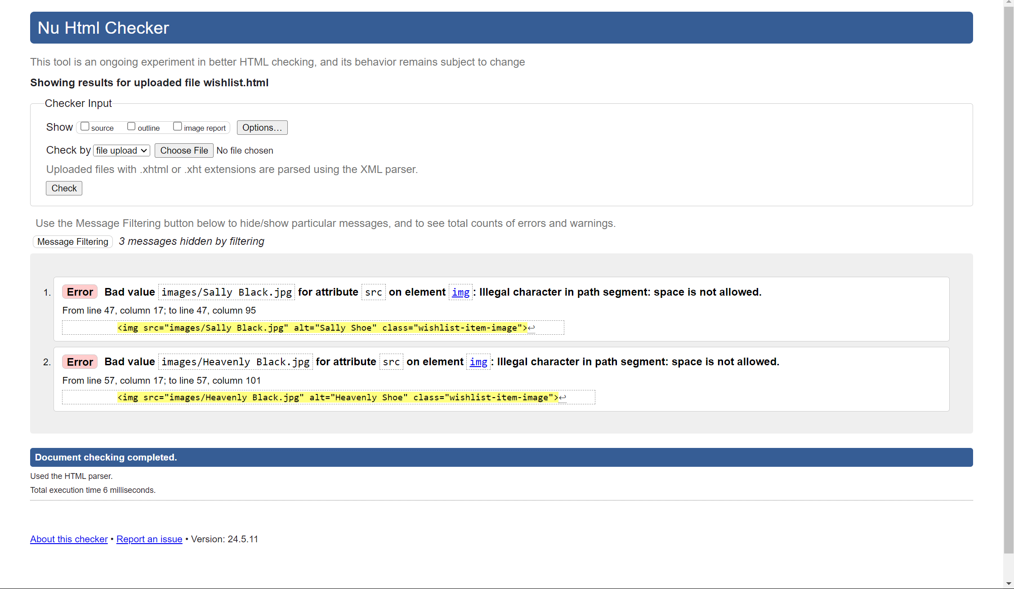

1. You must correct any accessibility issues and re-test your website until it displays correctly. Discuss this re-testing, including screenshots of different versions.

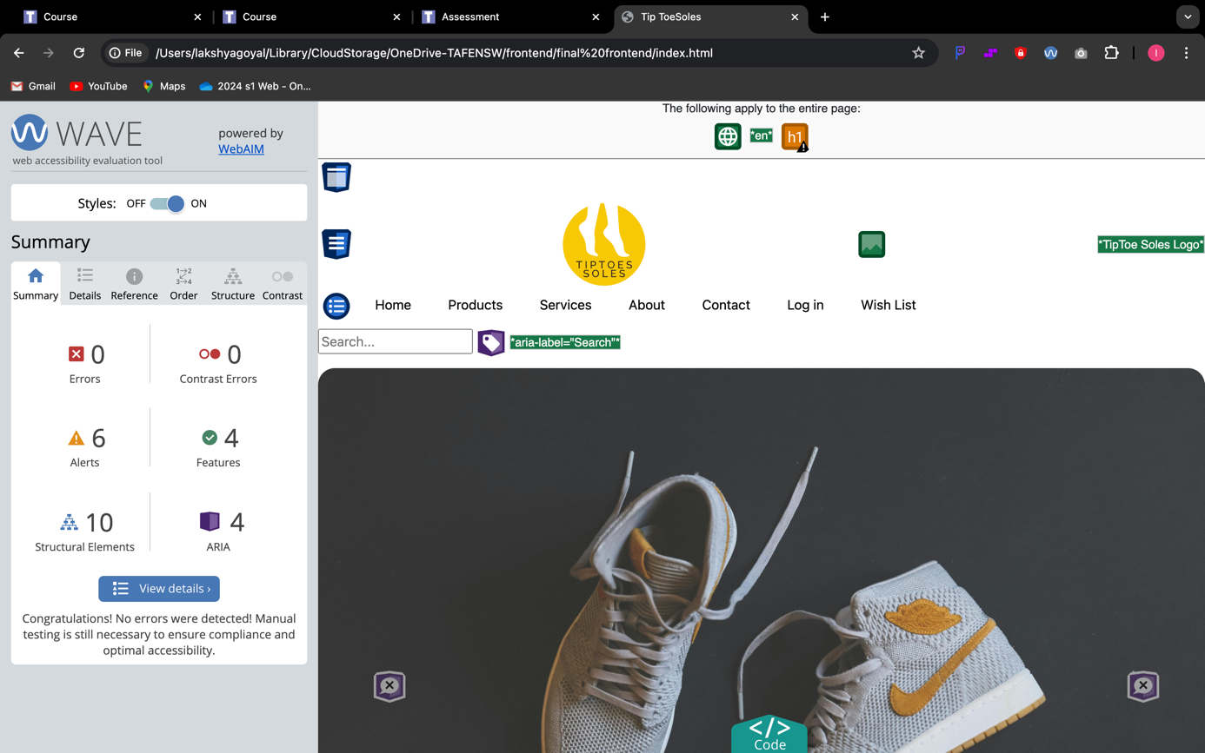

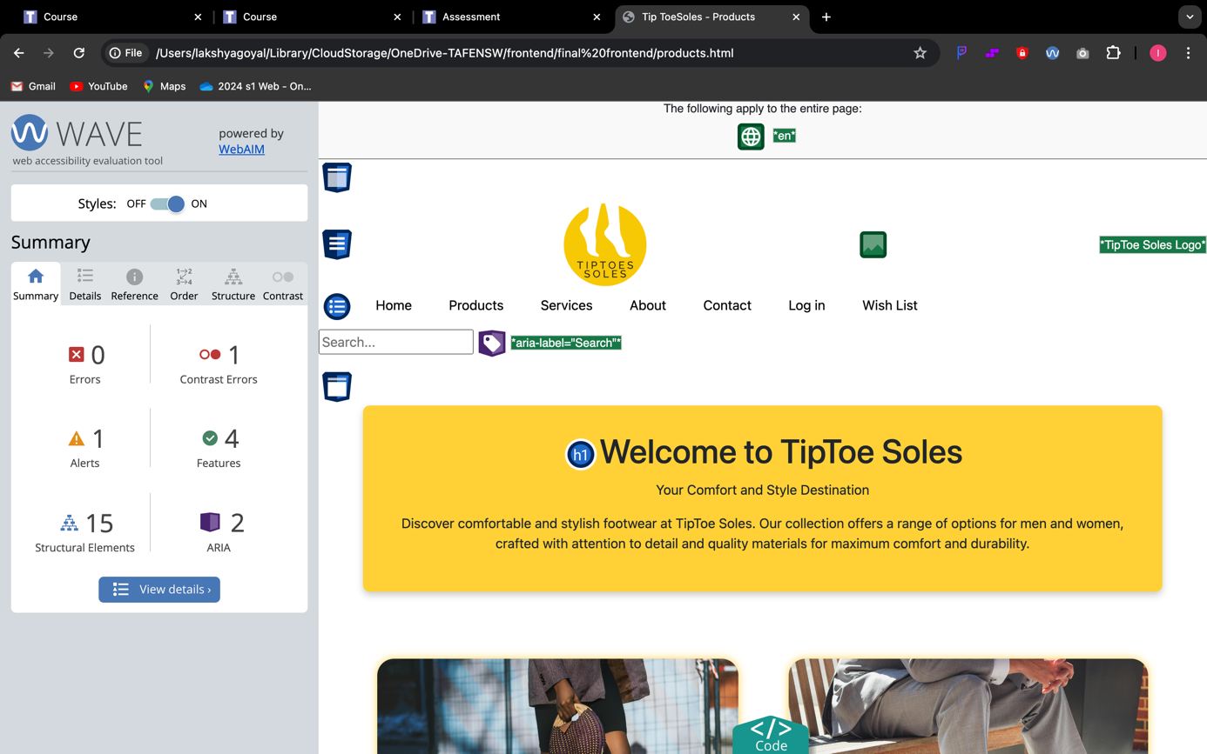

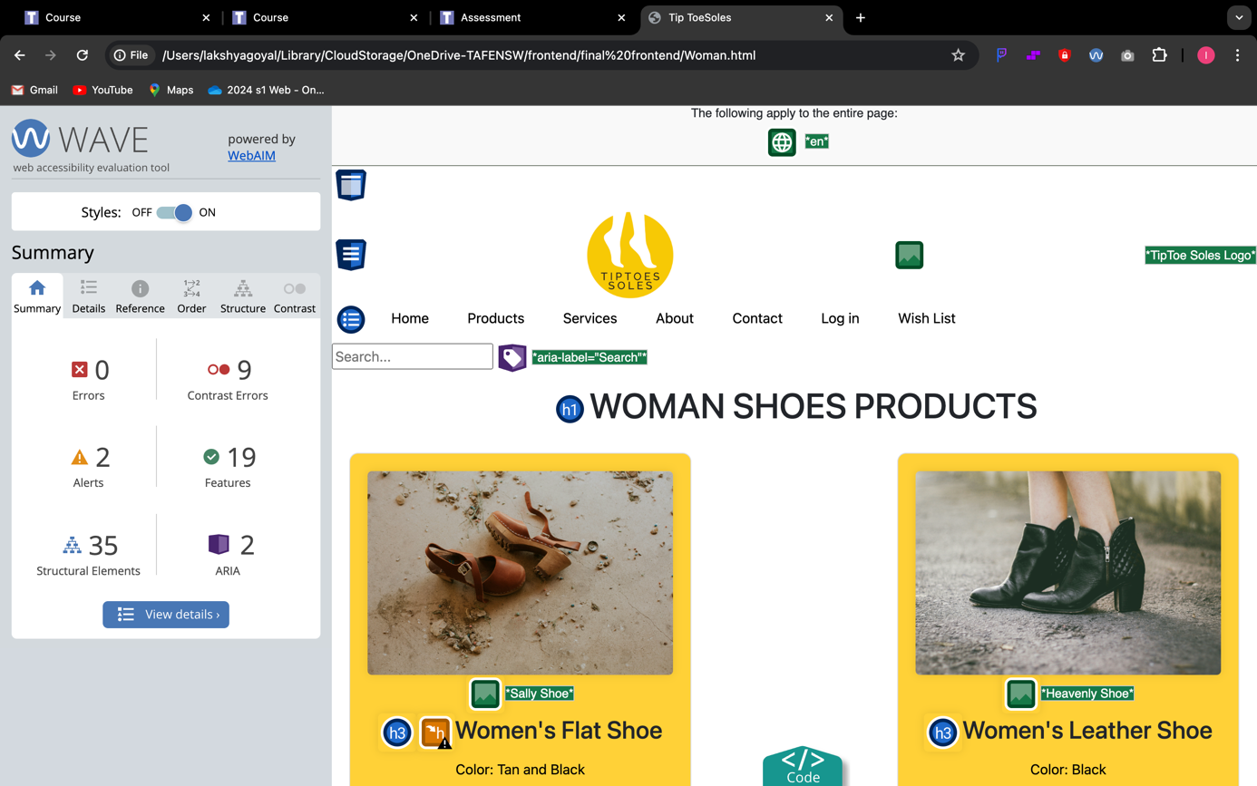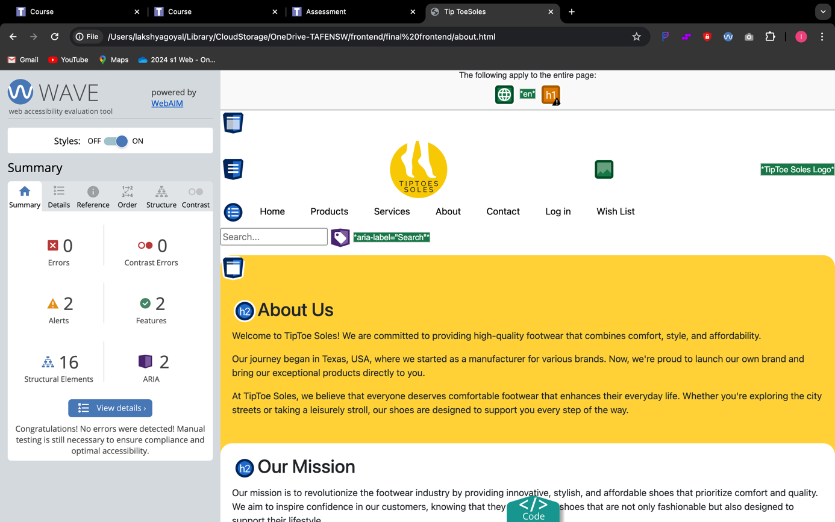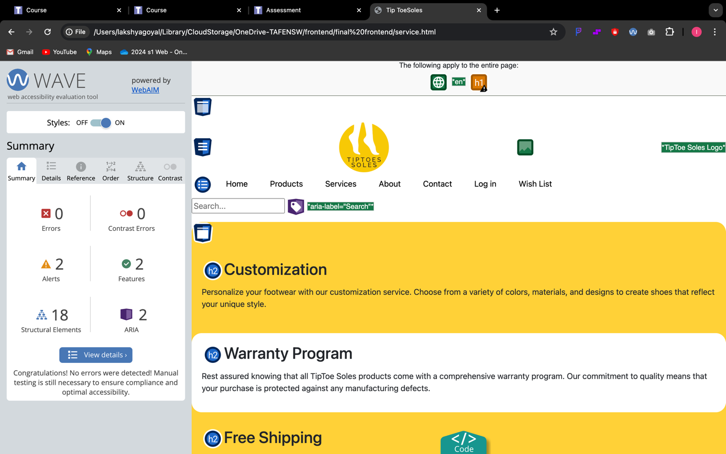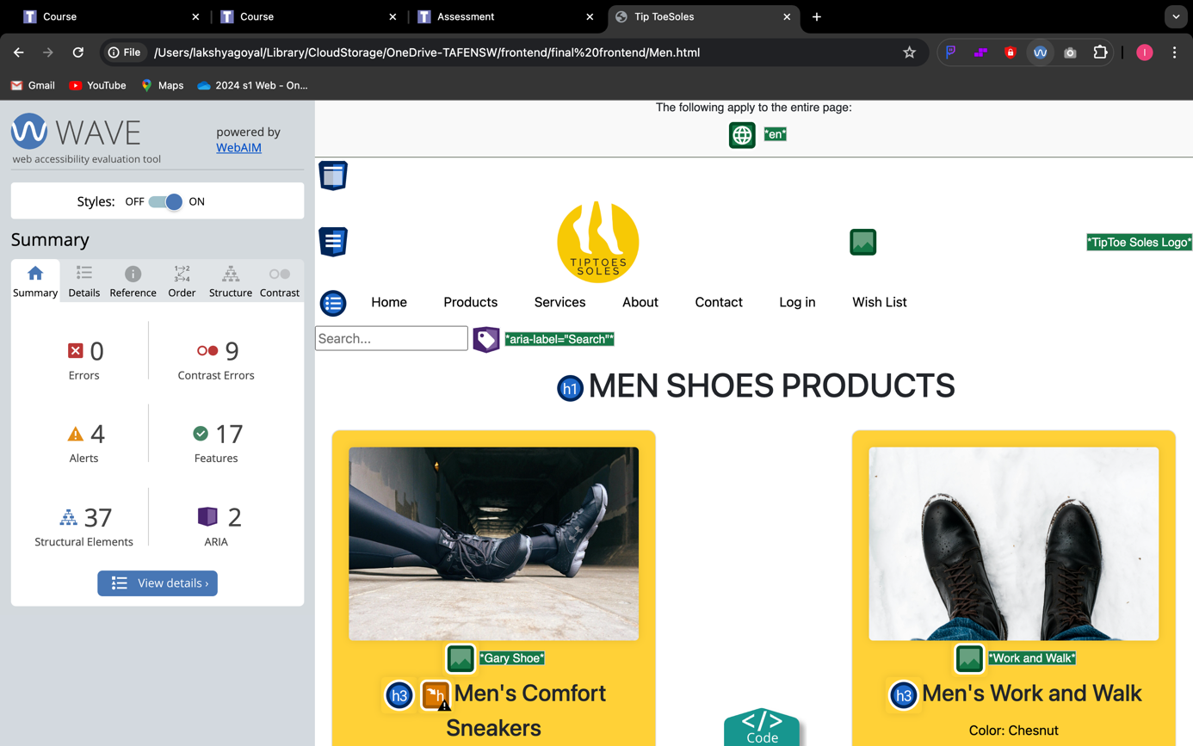

1. 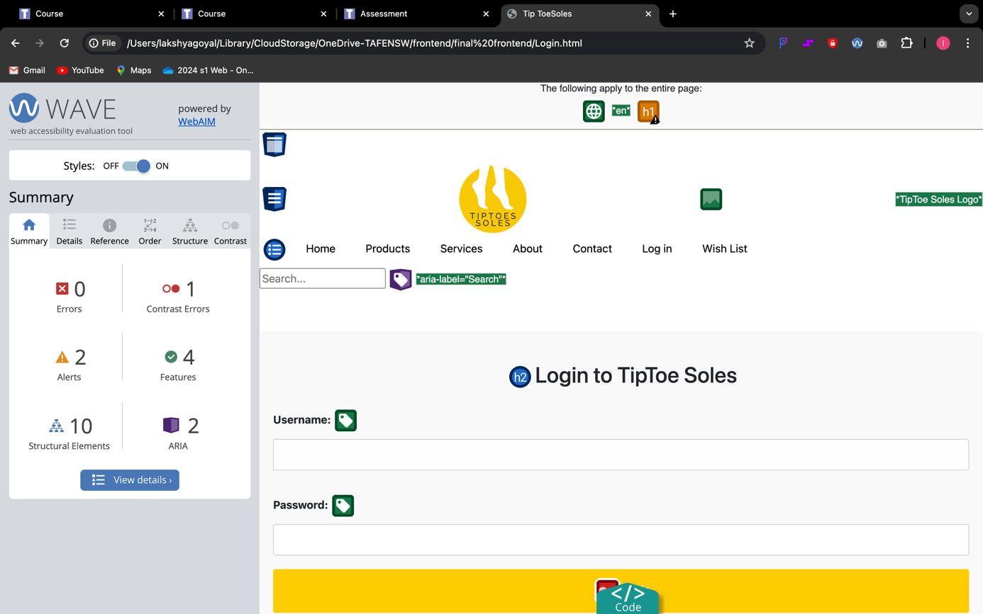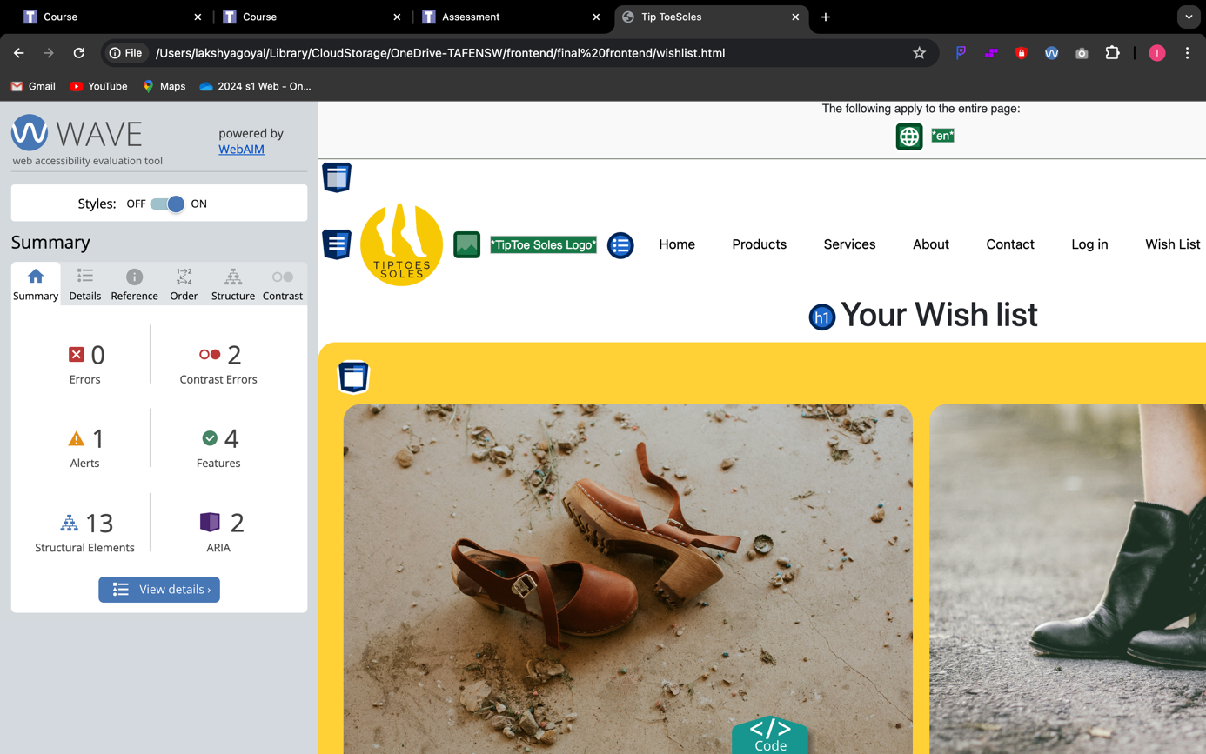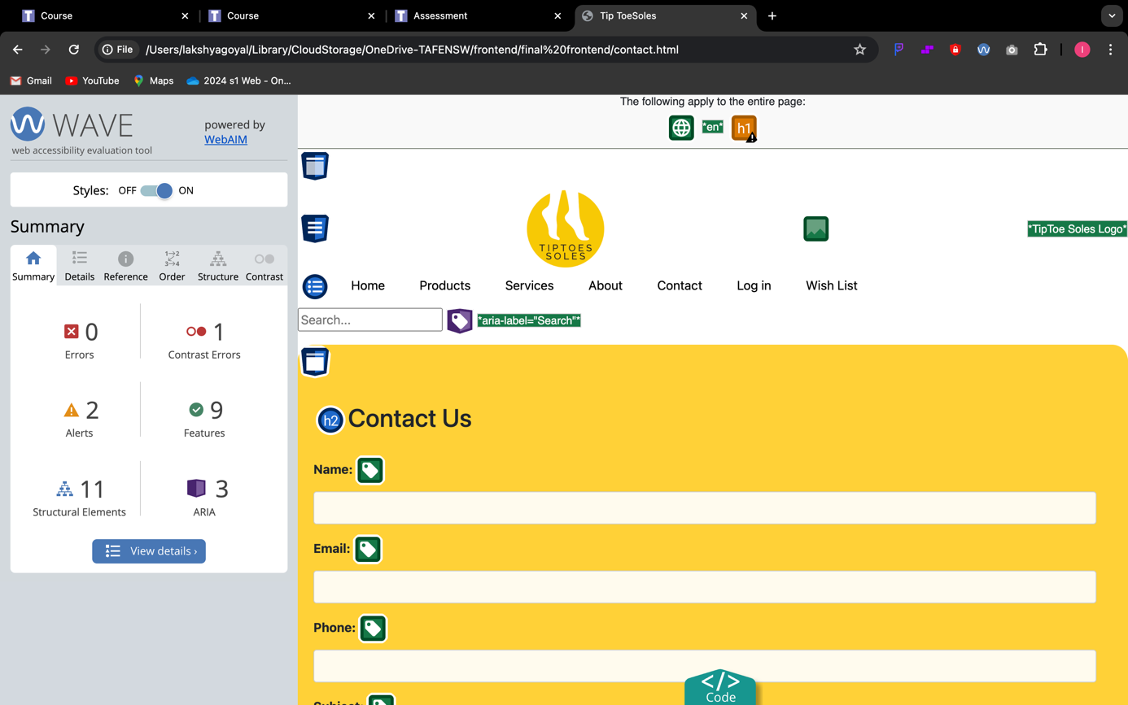
2. For the issues detected, use troubleshooting techniques and problem-solving processes to determine possible resolution. Take screenshots of the error before and after troubleshooting.

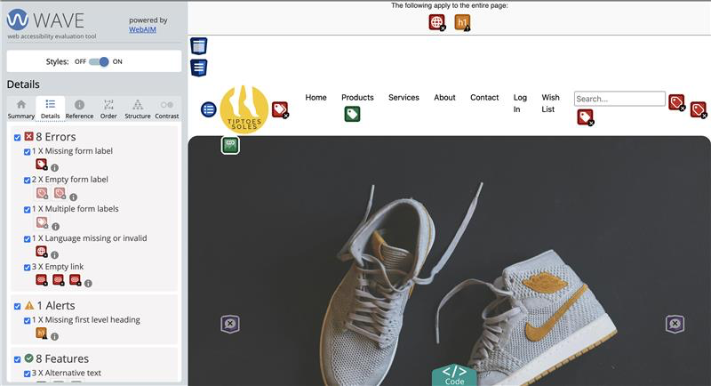



I rebuilt the Nav bar

1. Explain the testing process and the results, including any outstanding issues and corrective actions.

The testing process using the Wave Chrome extension revealed significant accessibility issues with the website's navigation bar, prompting a complete rebuild. The extension likely flagged issues related to color contrast, label associations, and semantic structure. Recognizing the importance of accessibility, the decision was made to overhaul the navigation bar to ensure compliance with standards and improve the user experience for all visitors, including those with disabilities or using assistive technologies. While specific details about the original issues aren't provided, the corrective action involved creating a new navigation bar with accessibility in mind, focusing on clear labels, semantic markup, and adequate color contrast. Moving forward, regular testing and maintenance will be crucial to ensuring ongoing compliance with accessibility guidelines and promptly addressing any future issues that may arise. This proactive approach demonstrates a commitment to inclusivity and accessibility, enhancing the website's usability and ensuring equal access for all users.

1. Suggest a process/procedure to be followed to ensure data security and safety.

Ensuring data security on a website involves a multifaceted approach to safeguarding sensitive information from unauthorized access or breaches. Initially, identifying the types of data collected and conducting a thorough risk assessment are crucial steps. Implementing security measures such as HTTPS encryption, firewalls, regular software updates, strong authentication, and data encryption are essential to protect data both in transit and at rest. A robust access control system, regular backups, monitoring, and logging further fortify defences. Additionally, drafting a comprehensive privacy policy and obtaining user consent, along with staff training and awareness programs, foster a culture of data security. Developing an incident response plan and conducting regular audits ensure preparedness and compliance with regulations. Careful consideration of third-party services' security standards is also imperative. This ongoing process of continuous improvement, adaptation to emerging threats, and adherence to evolving best practices strengthens data security and fosters user trust in the website's integrity.

1. Check text equivalent for every non-text element and confirm text-only pages are logical and accessible.

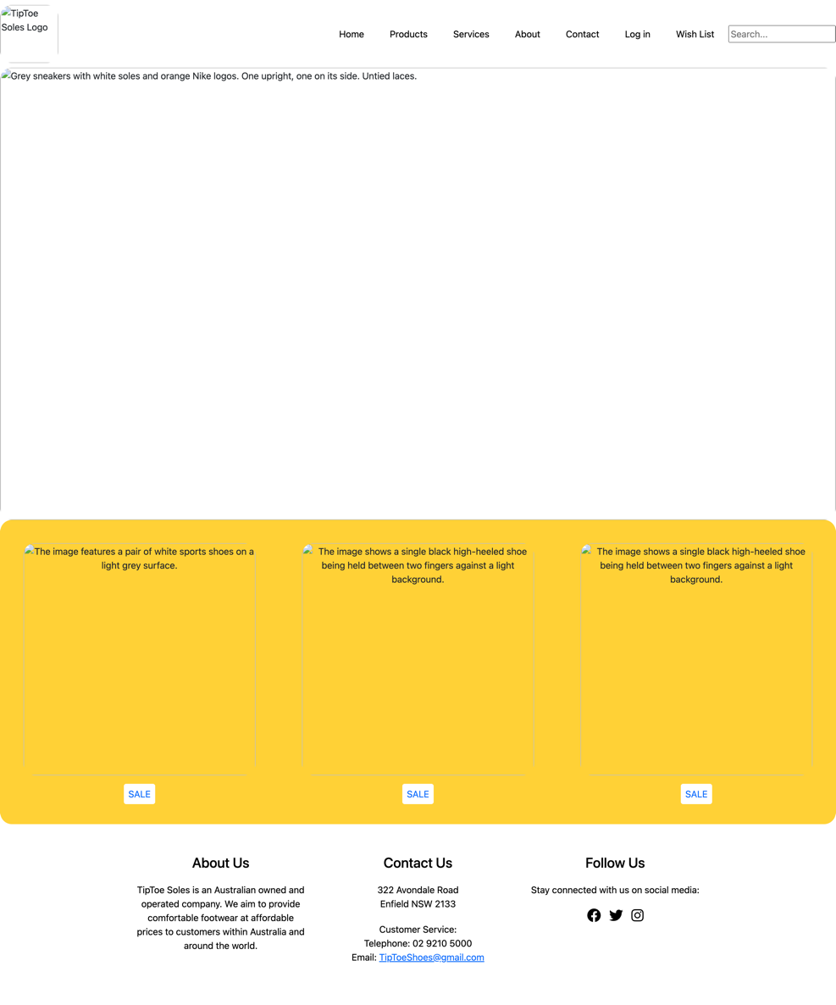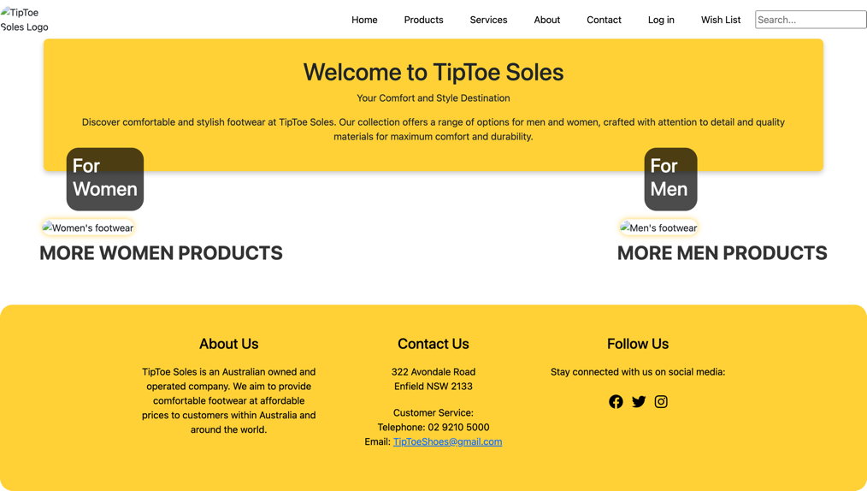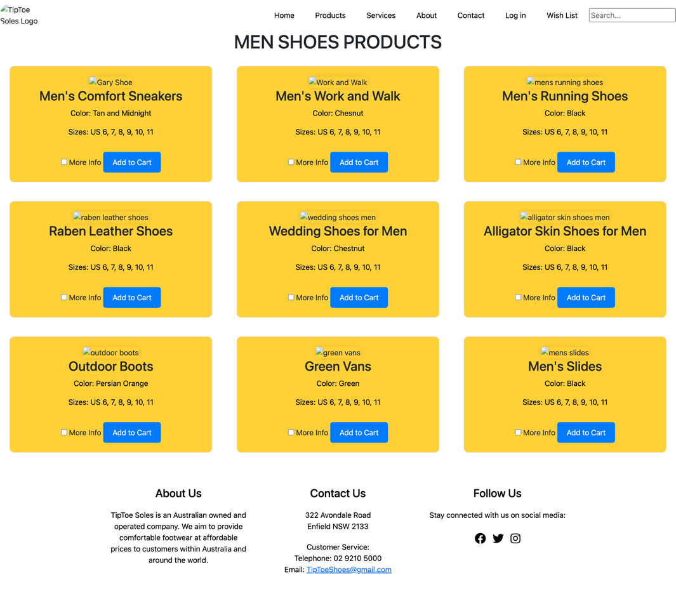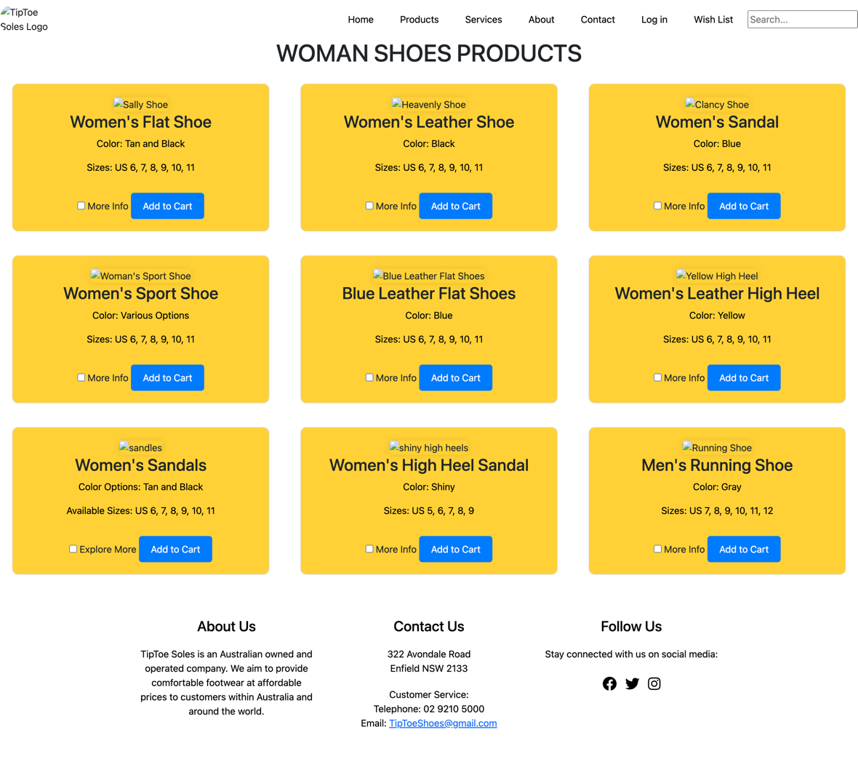

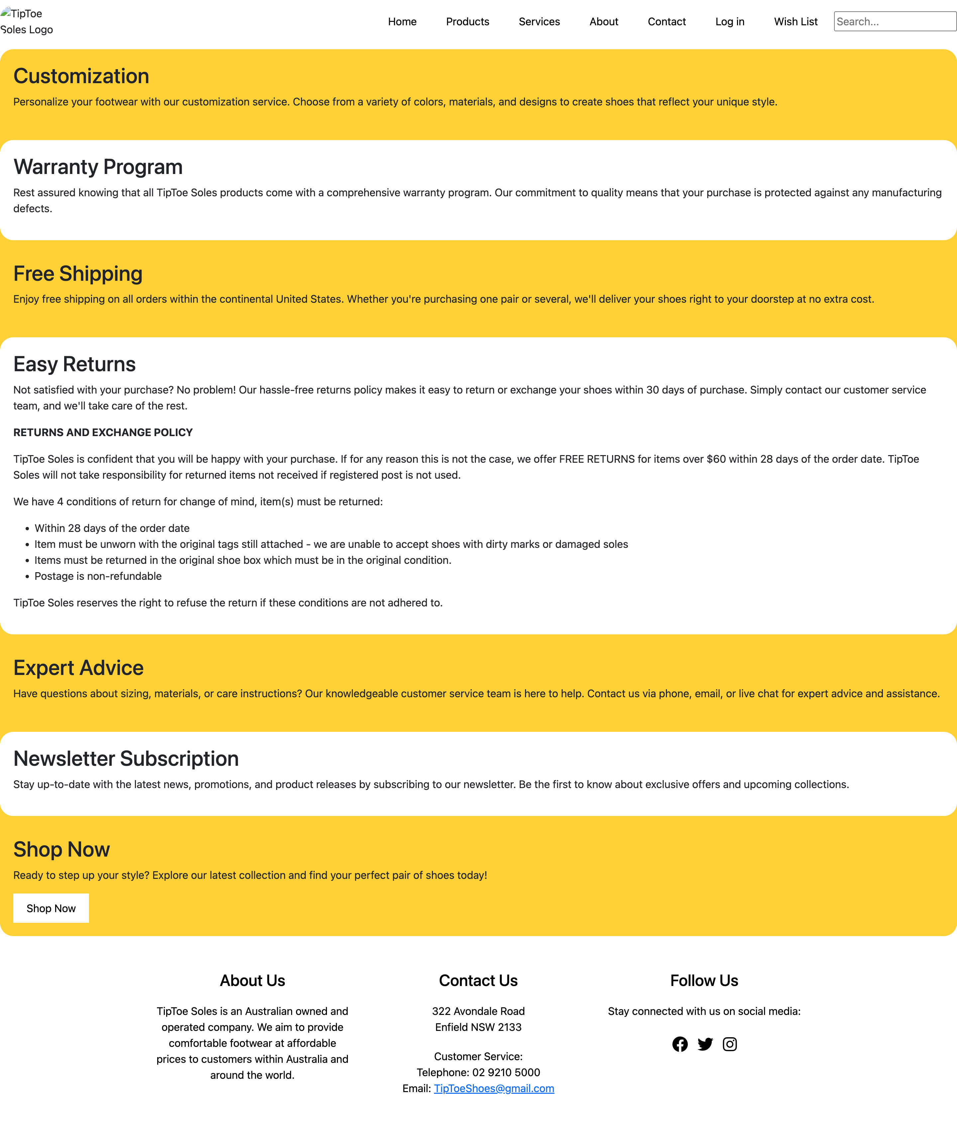 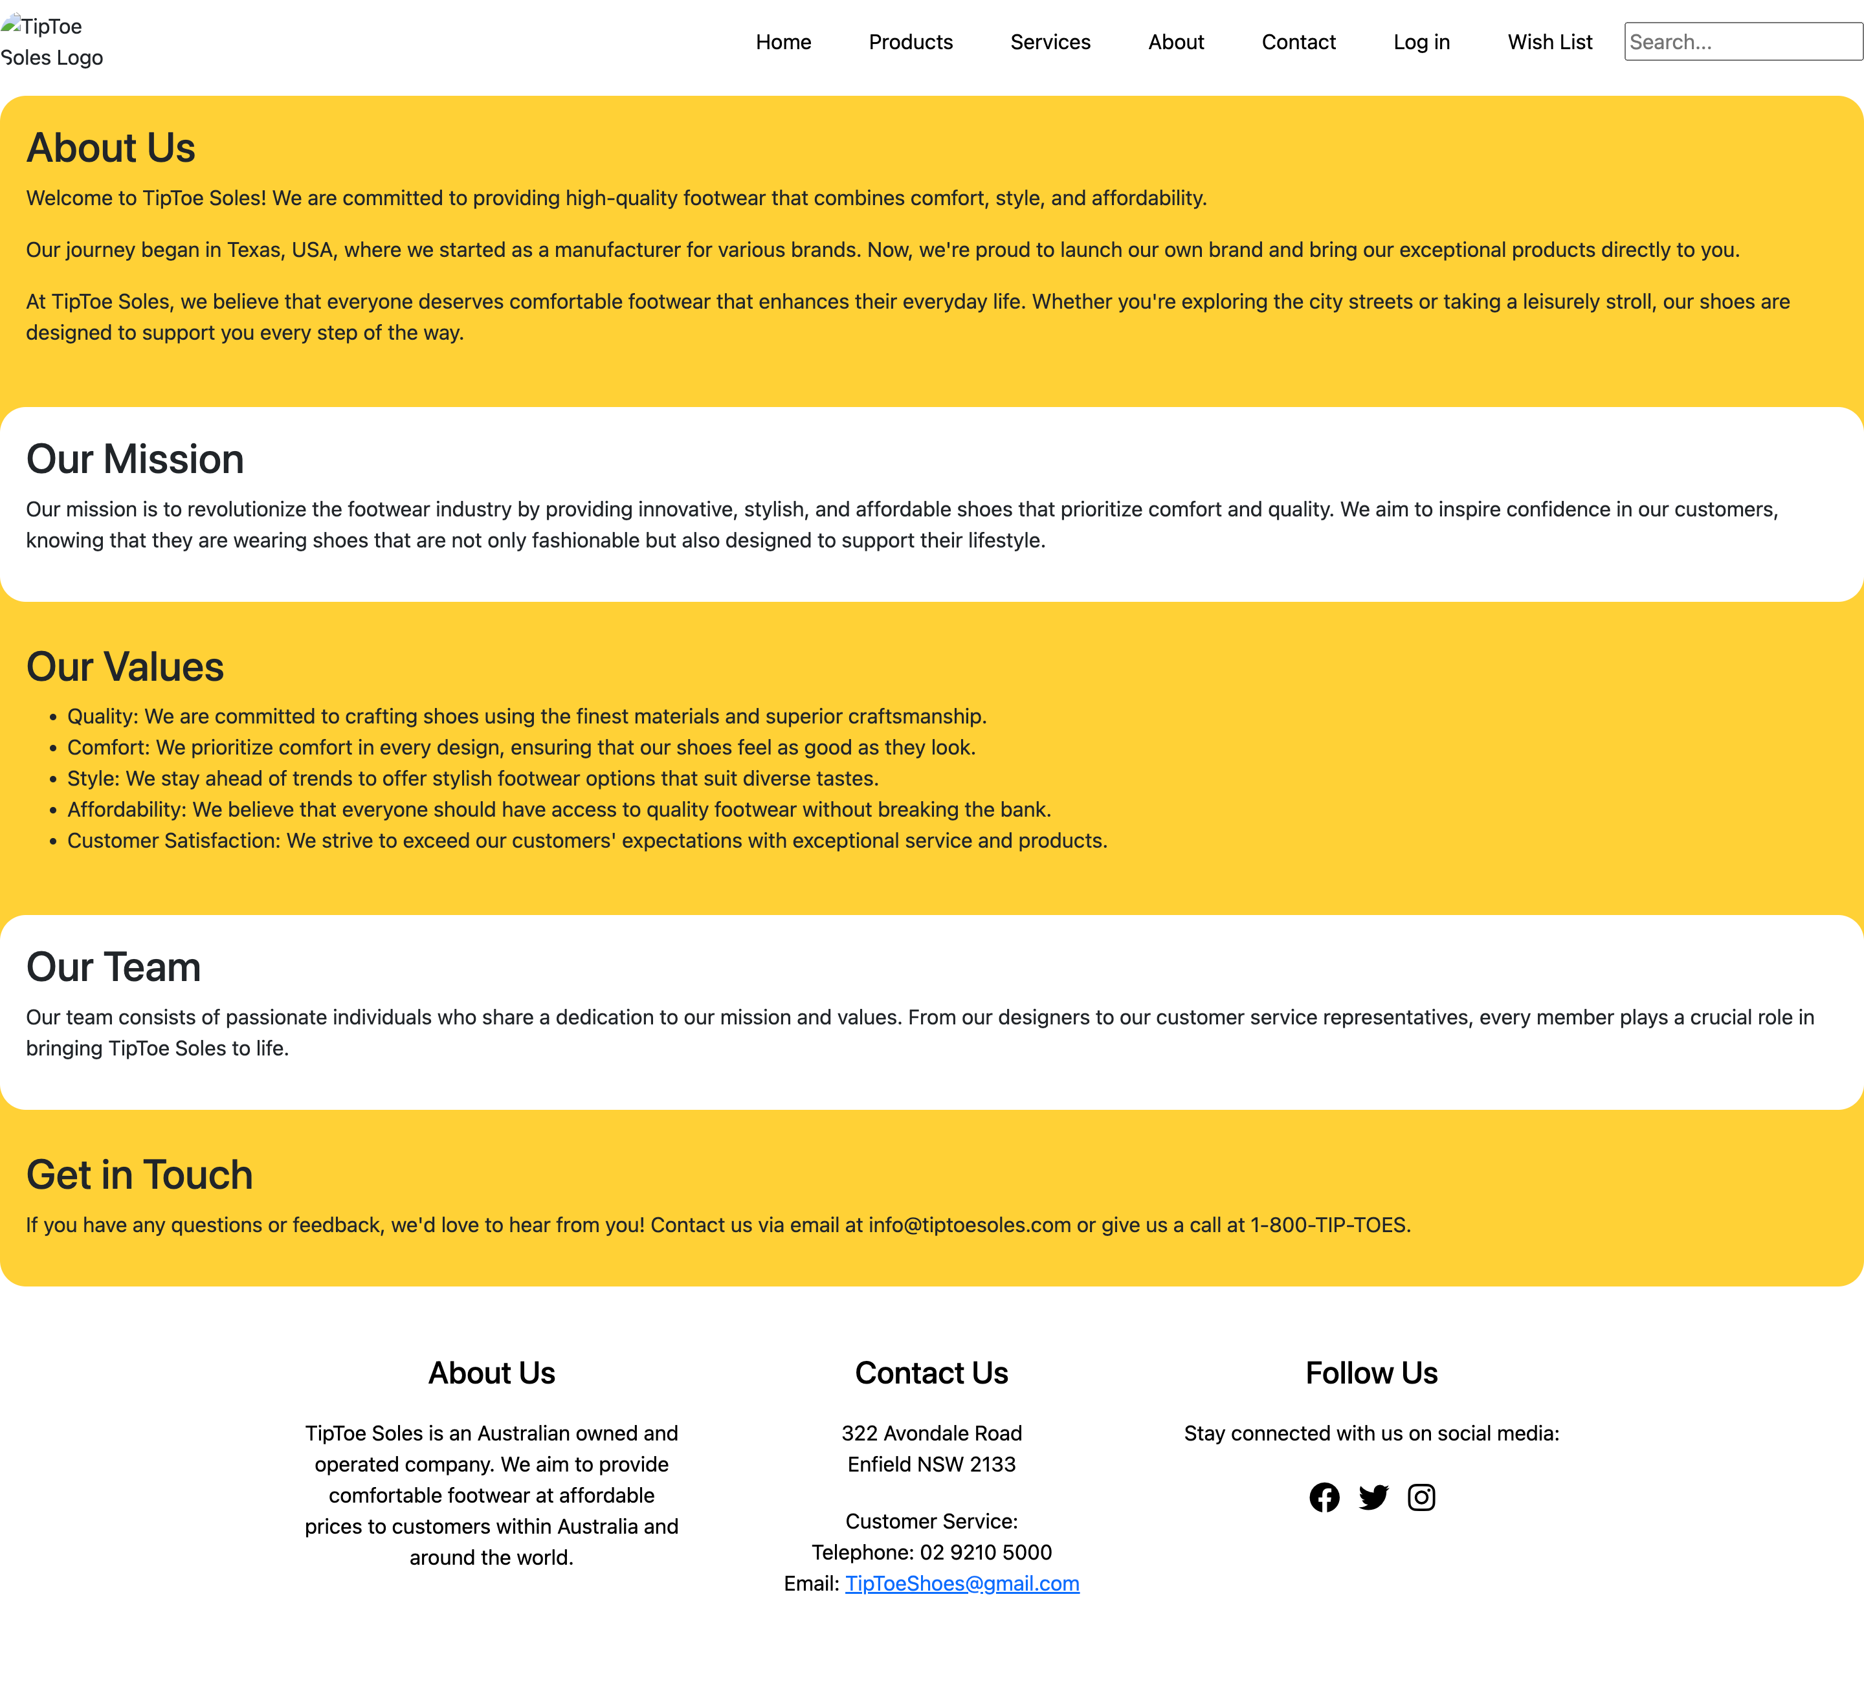 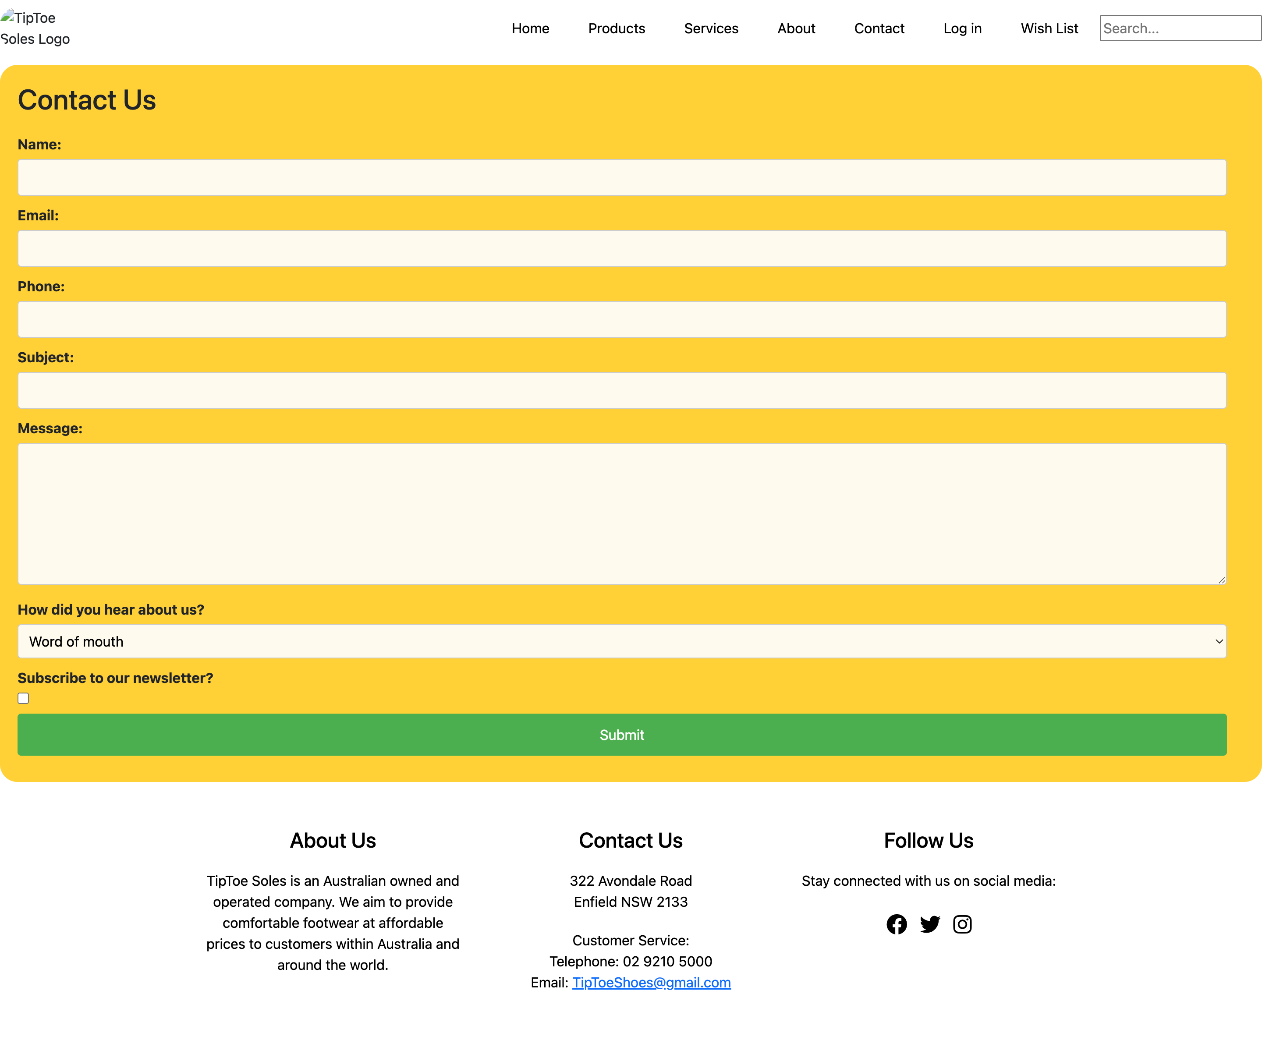 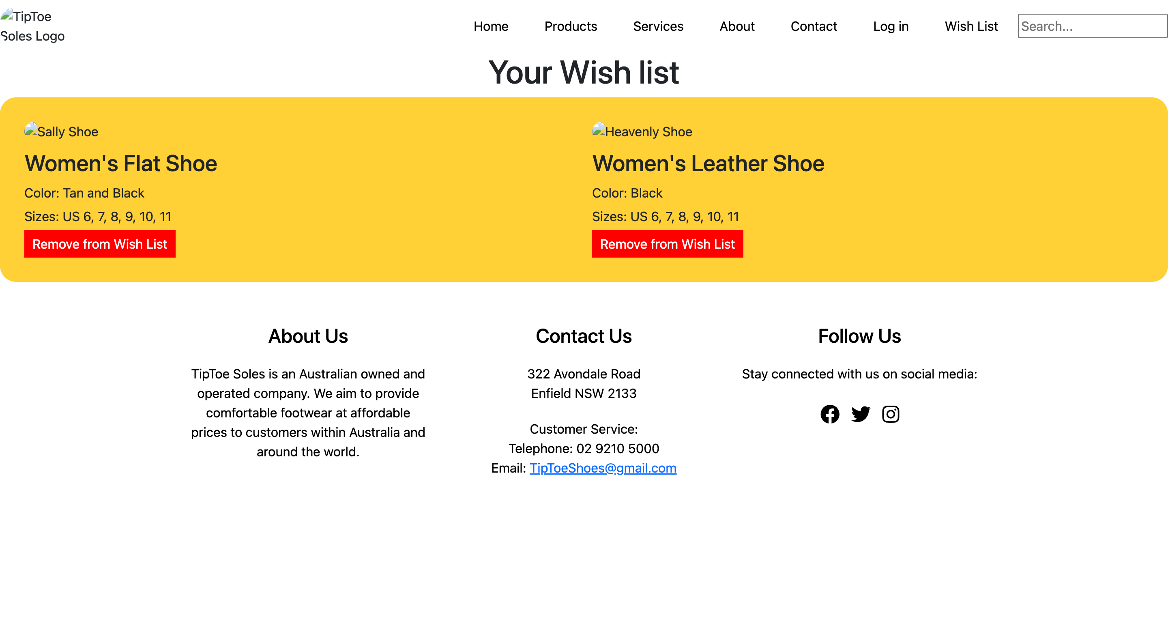

1. Demonstrate document can be read without style sheets. Check and confirm information and pages are not dependent on colour and can operate in monochrome environment.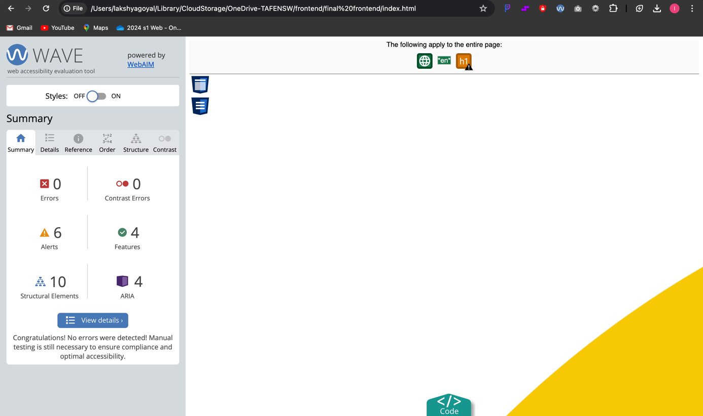
2. Verify pages operate on text-to-speech browser.  
   it reads out the information using chrome extension

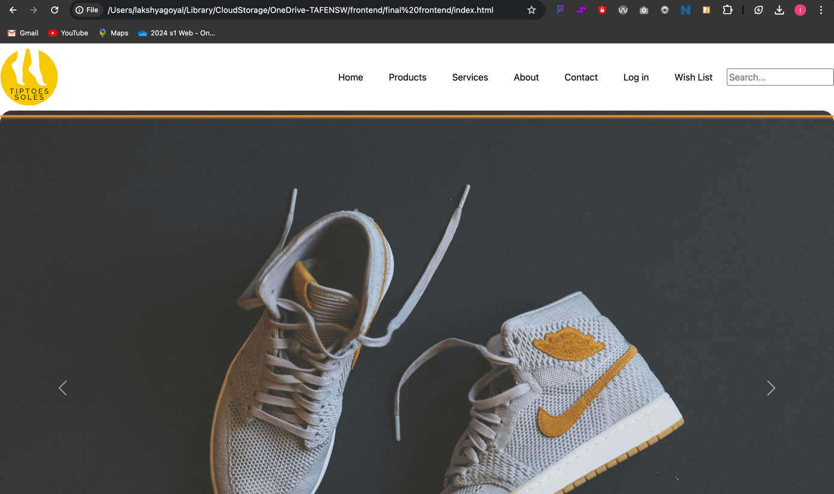

## Part 5: Taking feedback from the user

Once the desired product is ready and delivered to the client, it is imperative to take feedback on the same. A feedback documents how you performed, were the requirements met within time and budget, and how satisfied is the client with your work. In this section, we will be creating a feedback document and a project sign off document.

### Task 1 – Prepare the feedback form

When the website development work is complete and is finally delivered to the client, for any organization, taking the feedback from the client is crucial. The feedback shall enable the Gelos team to ascertain how they performed, take learnings for the future projects, and document how satisfied was the client with the work.

Use MS Word to prepare a sample feedback form to record the feedback from the client.

You must not use the internet for help, use the correct jargons, and the same template provided to present the answer.

Feedback Form

Project Name: TipToe Soles Website Development

Client Name: TipToe Soles Management

Project Duration: March 2024 - May 2024

Project Objectives: Develop a responsive website for TipToe Soles to launch their own brand of footwear, meeting client requirements for minimalistic design, easy navigation, and compatibility with various devices.

Rate Your Satisfaction with the Following Aspects of the Project:

Communication with the project team

Timeliness of deliverables

Quality of work delivered

Adherence to project requirements

Comments and Suggestions: [Provide space for clients to provide additional comments and suggestions]

### Task 2 – Prepare the sign off form

Once all the obligations regarding the agreement and project have been completed at both ends, Gelos and the client in this scenario, a project sign off is obtained from the client. This document refers as an acceptance from the client that the product desired has been delivered and the project should now be closed.

This again is prepared and maintained by Gelos as the final document of the project.

Use MS Word to prepare a sample client sign off form.

You must not use the internet for help, use the correct jargons, and the same template provided to present the answer.

Client Sign Off Form

Project Name: TipToe Soles Website Development

Client Name: TipToe Soles Management

Project Duration: March 2024 - May 2024

Project Objectives: Develop a responsive website for TipToe Soles to launch their own brand of footwear, meeting client requirements for minimalistic design, easy navigation, and compatibility with various devices.

Project Deliverables:

Responsive website design

Integration of latest arrivals banner

Navigation menu implementation

Footer with policy links

Brand logo integration

Accessibility compliance measures

Payment gateway integration

High traffic handling and performance optimization

Legal compliance with state and local laws

## Part 6: Assessment checklist

The following checklist will be used by your Teacher/Assessor to mark your performance against the assessment criteria of your project. Use this checklist to understand what skills and/or knowledge you need to demonstrate during this assessment event. All the criteria described in the Assessment checklist must be met.

Table 2 Assessment checklist

| TASK/STEP # | Instructions | S | U/S | Assessor comments |
| --- | --- | --- | --- | --- |
| Part 1 Task 1 | Assess if the student is able to demonstrate the following:  Details of audience analysis in the template. |  |  | *Date of observation:*  *Assessors are to record their observations in enough detail to demonstrate their judgement of the students’ performance against the criteria.* |
| Part 1 Task 2 | Assess if the student is able to demonstrate the following:  Details of user requirements in the template. |  |  |  |
| Part 1  Task 3 | Assess if the student is able to demonstrate the testing approach, test case, testing checklist, and reasons for selecting the mark-up language. |  |  |  |
| Part 2 Task 1 | Assess if the student is able to demonstrate the following:  Document the website requirements in the template provided. |  |  |  |
| Part 2 Task 2 | Assess if the student is able to demonstrate the following:  Submit the content inventory, digital sitemap and digital wireframe screenshots as evidence |  |  |  |
| Part 2 Task 3 | Assess if the student is able to demonstrate the following:  Prepare an accessibility checklist as per the web standards, laws, and scenario provided. Also, list the benefits of integrating text-to-speech option. |  |  |  |
| Part 2  Task 4 | Assess if the student is able to uses clear and detailed verbal language in order to convey explicit information clearly, showcase active listening and questioning skills and provided satisfactory answers to the questions asked. |  |  |  |
| Part 3  Task 1 | Assess if the student is able to demonstrate the following:  Submit the code and the HTML link for the website developed as evidence. |  |  |  |
| Part 4  Task 1 | Assess if the student is able to demonstrate the following:  Test the website and complete the testing checklist.  Screenshots of testing website in two common browsers.  Provide screenshots of validating website.  Provide screenshots of testing different versions of the website.  Provide screenshots of before and after troubleshooting the issues detected.  Provide the testing process, results, outstanding issues and corrective actions taken.  Provide points in support how data can be secured. |  |  |  |
| Part 5 Task 1 | Assess if the student is able to demonstrate the following:  Prepare the feedback form. |  |  |  |
| Part 5 Task 2 | Assess if the student is able to demonstrate the following:  Prepare the client sign off form. |  |  |  |

## Assessment feedback

*NOTE: This section must have the Teacher/Assessor and student signature to complete the feedback. If you are submitting through the TAFE NSW online learning platform, your Teacher/Assessor will give you feedback via the platform.*

### Assessment outcome

Satisfactory

Unsatisfactory

**Assessor feedback**

Has the assessment declaration for this assessment event been signed and dated by the student?

Are you assured that the evidence presented for assessment is the student’s own work?

Was reasonable adjustment in place for this assessment event?

*If yes, ensure it is detailed on the assessment document.*

*Comments*:

### Assessor name, signature and date

### Student acknowledgement of assessment outcome

*Would you like to make any comments about this assessment?*

### Student name, signature and date